**Full-stack web development**

* Front end/client-side
  + Delivering content to the user
  + HTML, CSS javascript
* Back end/server side
  + Implemented with back end support
  + PHP, Java, ASP.NET, Ruby, Python
* 3 – tier architecture of web development
  + Presentation layer
    - Concerned with UI related issues
  + Business logic
    - Data validation
    - Dynamic content processing
    - Generating the content to be delivered to the user
  + Data access layer
    - Data persistence
    - Data access through an API
    - Concerned with how we store and interact with the data (typically in the form of a database

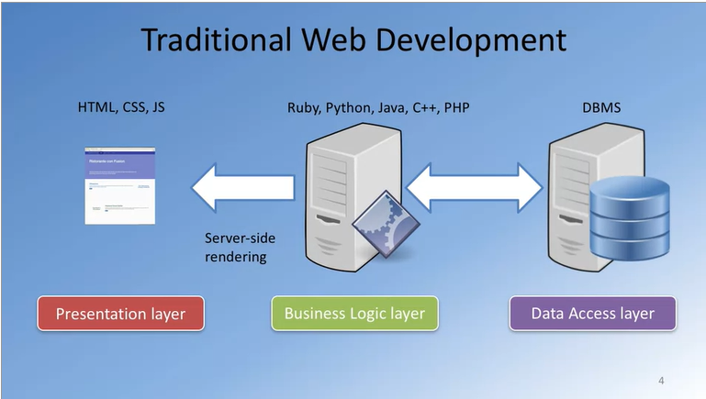

* Full stack Javascript development

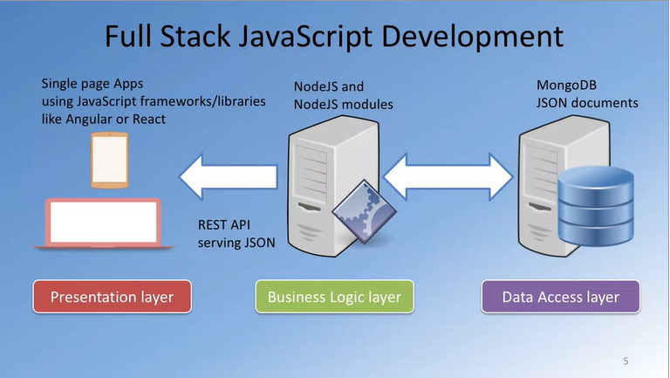

* For this course

